1. Finish a Xamarin UITeat project Test run Locally  
   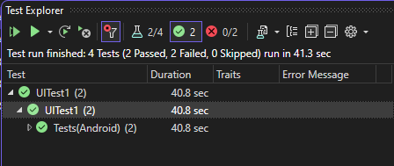  
   The main problems I encountered are as follows.
2. First of All, When Build the UITest Project, the error like below can be ignored, it will not affect the Test Running Correctly. Refer to this [link](https://social.msdn.microsoft.com/Forums/en-US/ab852fc5-ad64-4c38-9c4b-dfc4aee5e6ac/xamarinuitest-project-targeting-net-framework-vs-net-core-amp-net-standard-implentation?forum=xamarinforms).

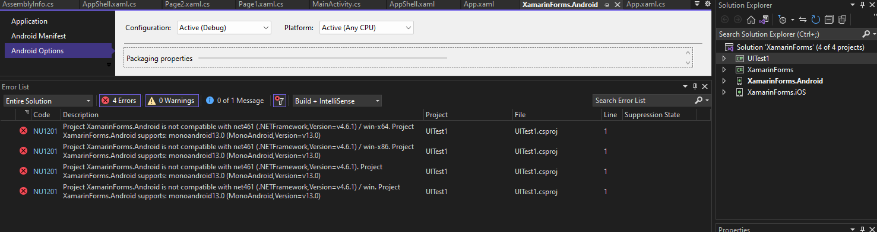

1. Add A reference of Xamarin.Android Project from UITest Project, so that the Xamarin.UITest code can access and reference the class in Xamarin.Forms and Xamain.Essential Pages. Otherwise, it has to add these necessary packages independently using NuGet Pages.

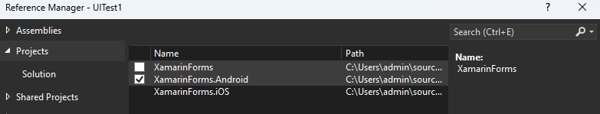  
  
3.How to Run the UITest Project after completing the test code?  
Click the Test bar on the Upper Edge of Visual Studio, and click the Run All Tests in the drop-down menu.  
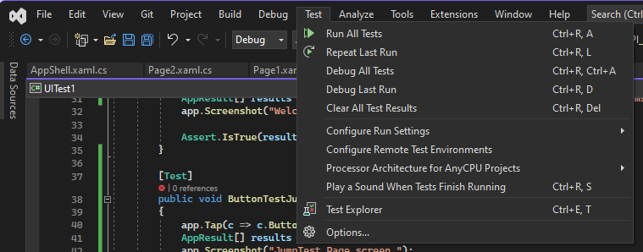

4.Befor the test, uncheck the option “Use the Fast Deployment (debug mode only)”, then rebuild the Xamarin.Android Project. Or the output apk cannot be tested normally.  
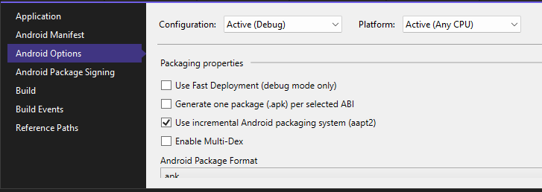

2. Complete testing in the cloud  
go to the test Page, provision the necessary information and copy the command.  
to let the program know the testcloud.exe file path as the error note,  
add the extra option --uitest-tools-dir pointing to the directory of testcloud.exe  
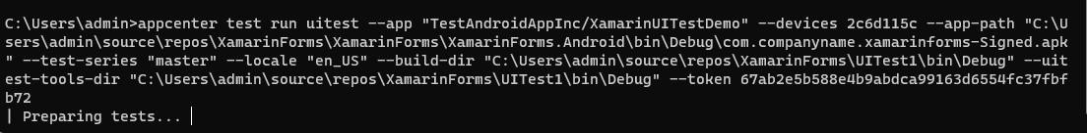

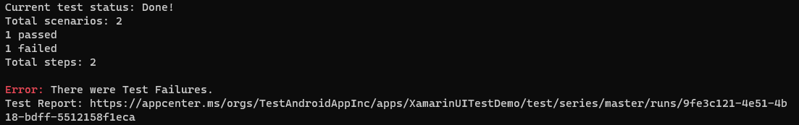  
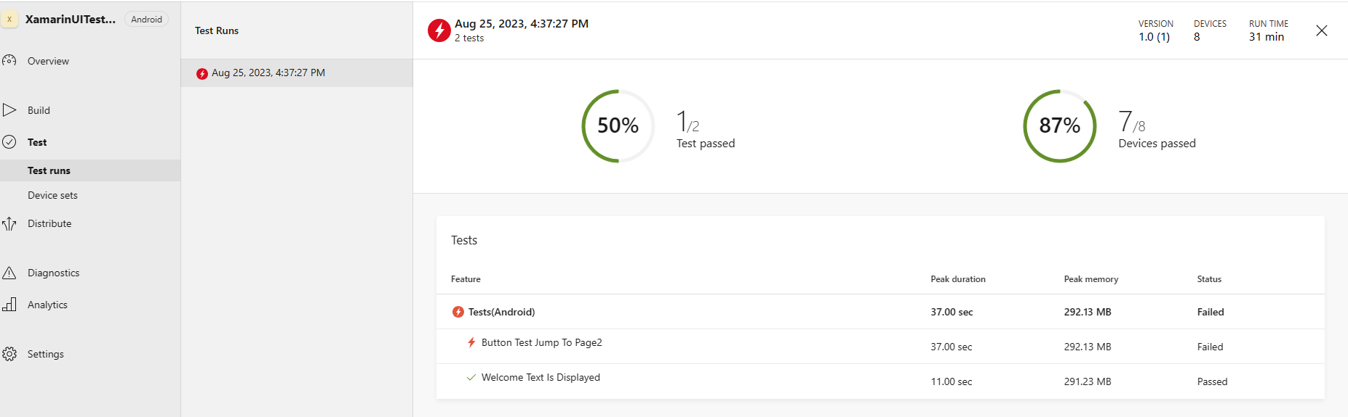

3.